Michael Smith

CSE460

Lab 2

20 Possible Points

1. ) Basic Shell Programming
   1. How to write shells Exercise -

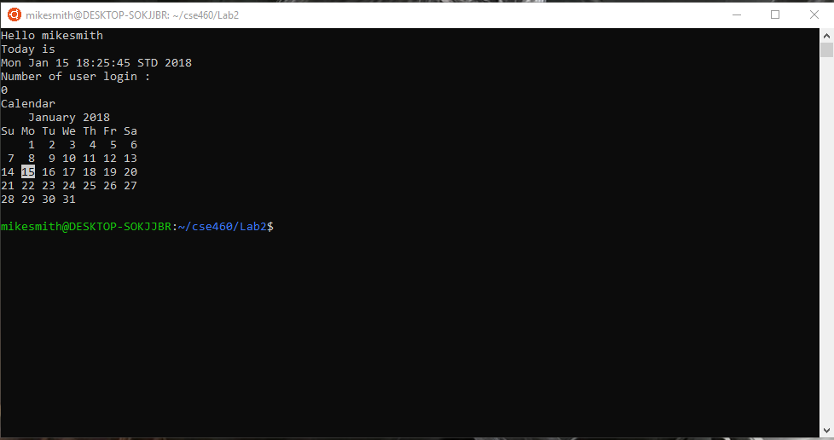

The difference is that when executing the ./ginfo the output is as intended. But when executed as . ./ginfo the shell opens a new window and is closed upon exit. This is due to the final line being exit 0.

* 1. Variable Exercise -

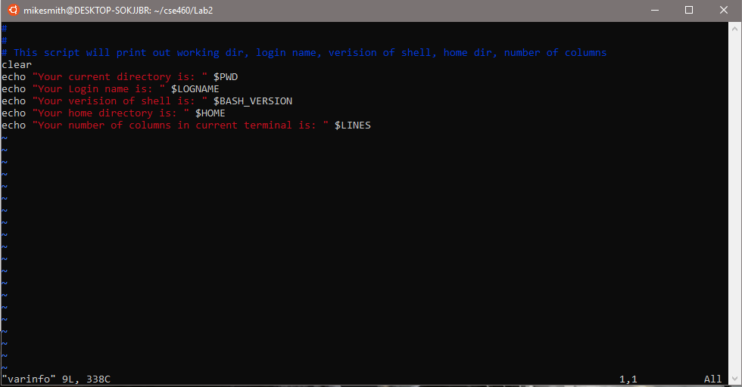

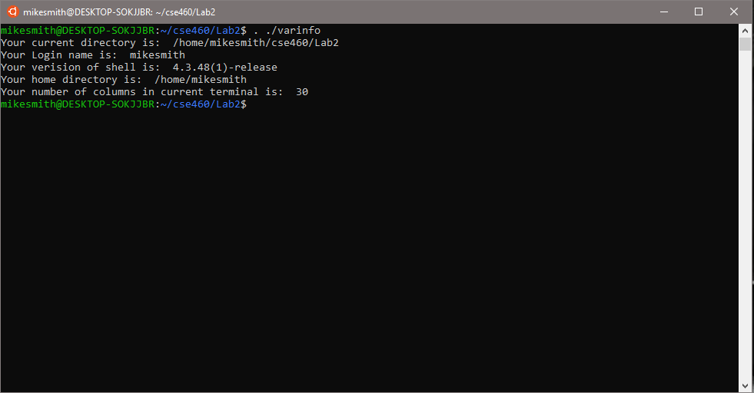

* 1. User Defined Variables Exercise -

1.) To define the varible x with the value of 10 and print it you use:

$ x=10

$echo $x

2.)To define varible xn with the value of 'Rani' and print it you use:

$ xn=Rani

$echo $xn

3.)To print the sum the sum of two number you do:

$ expr 6 + 3

4.) To define the two variables and print the quotient you do:

$ x=20

$ y=5

$ expr x / y

5.) To modify question 4 to store quotient in z you do:

$ x=20

$ y=5

$ z='expr x / y'

$ echo $z

Shell script:

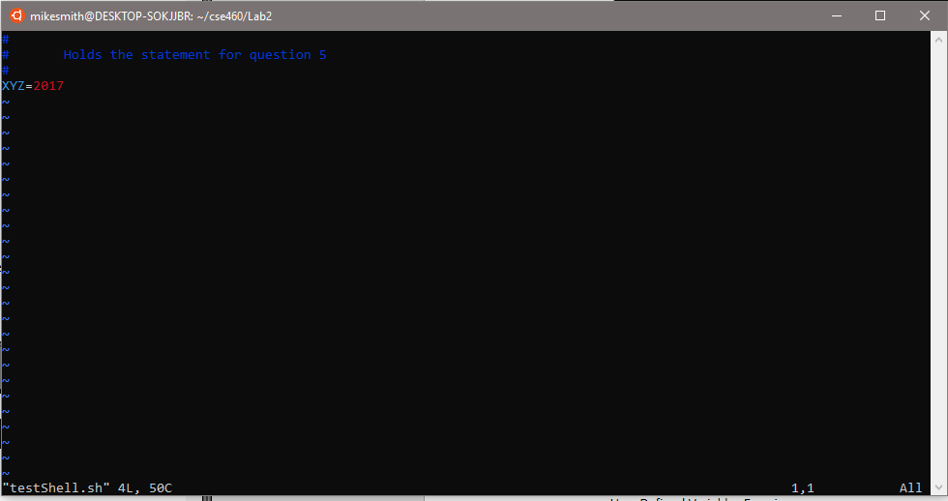

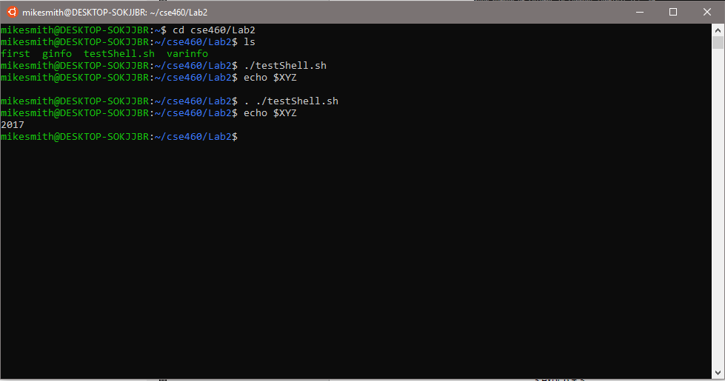

When executed as ./testShell.sh the echo command for XYZ displays nothing, while executed as . ./testShell.sh the echo command properly prints out the value. The difference being the . Command executing the shell in the current shell and not creating a new copy of a shell.

2.) Awk Exercise -

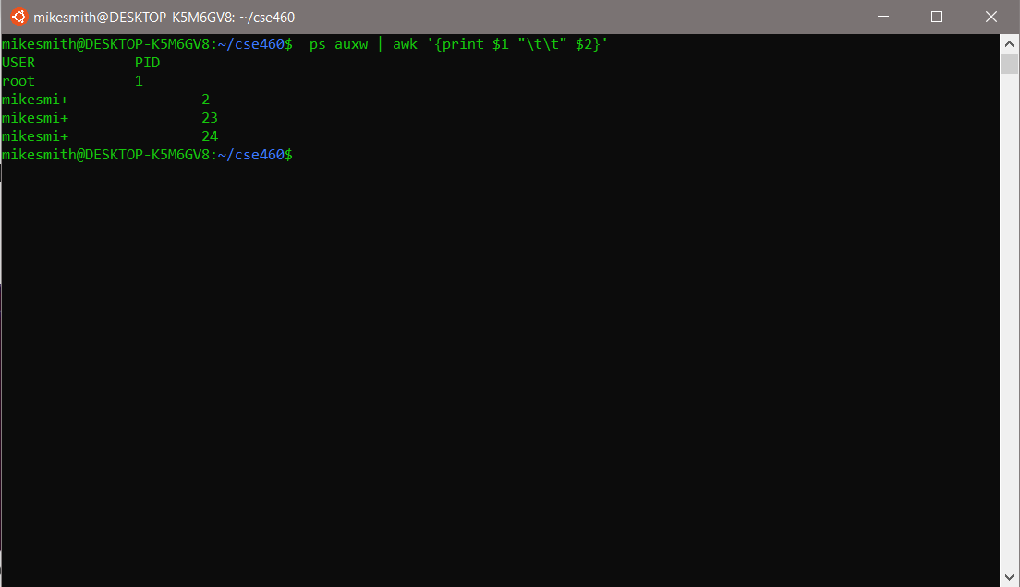

This command will output the process table. You see two lists, the first being the name, with two tabs in the middle and the process ID number. This command outputs ps auwx to awk as the input.

3.) Kill command

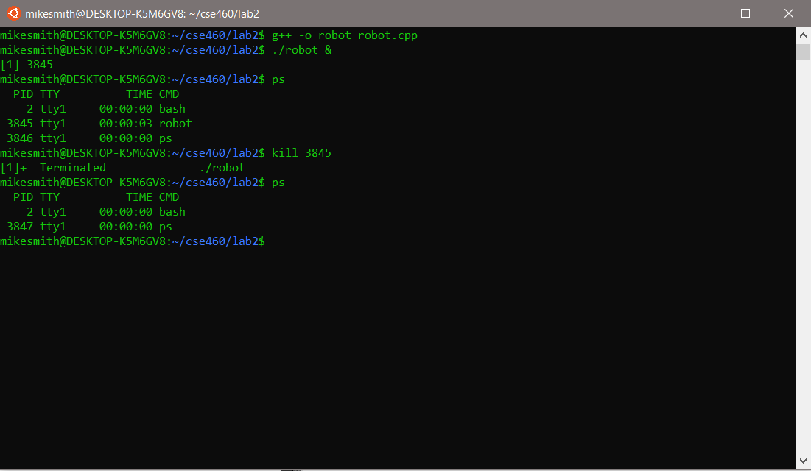

Nice and renice

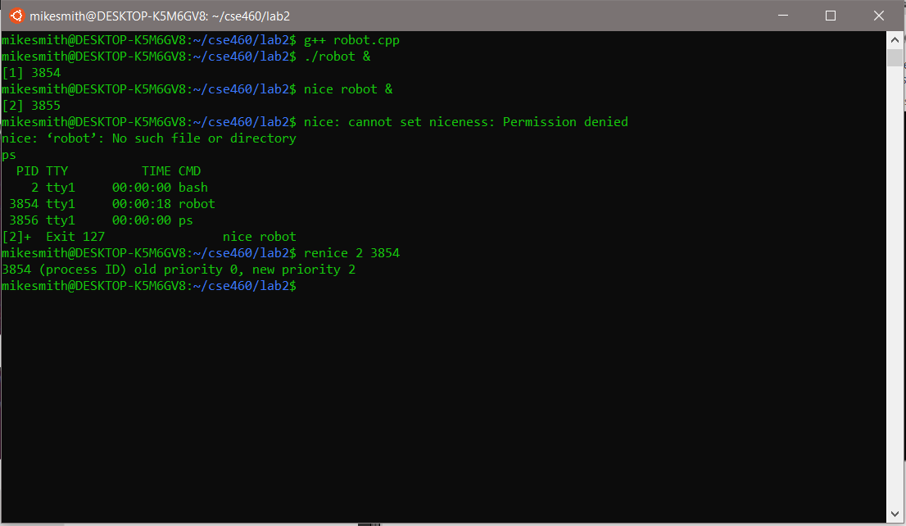

4.) Starting a new process

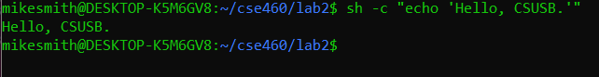

Test_system.cpp

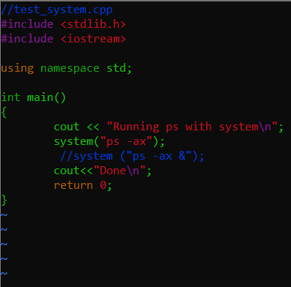

Compiled without the &

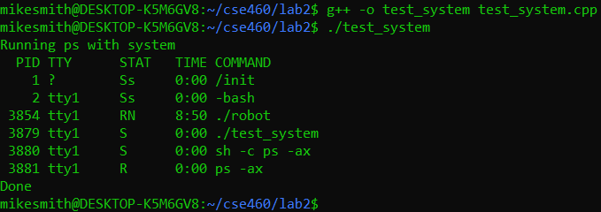

Compiled with the &

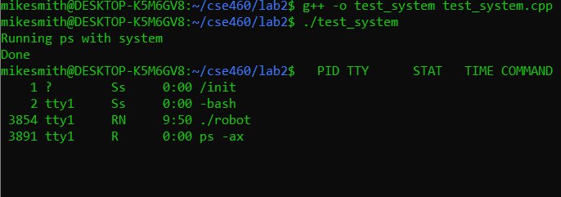

With the '&' the process is started as a background process that can be killed. While without the '&' the program is executed and then exits on finish.

5.) Shell Programming Practice

What does the option "-v" in the grep command do?

The –v command inverts the matching, to force select non-matching lines.

TerminateProcess

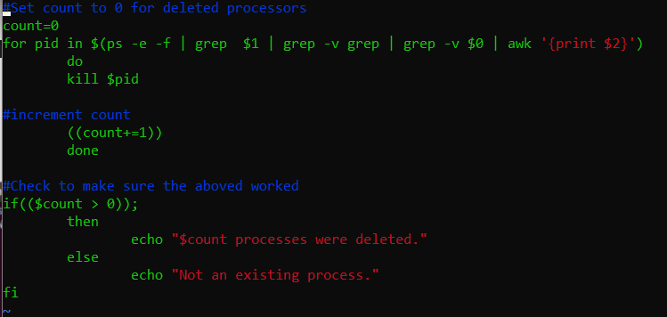

Execution of Terminate Process

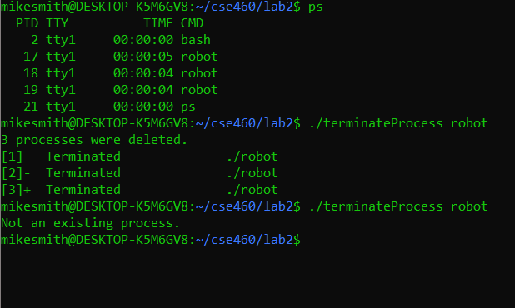

6.) Evalutation

This lab was to cover the basics of shell commands and to explore some possibilities with shells. We also covered user created variables and system commands. There was a lot of content covered in this lab, but creating the final shell to kill a specific process I spent the most time on to finish. I was able to successfully execute and answer each step of the lab.

Score 20/20